**Finding the sweet spot in camera trapping: a review of camera trap papers to test for reported sampling effort in population estimates.**

Nargol Ghazian1* and Christopher J. Lortie1, 2

1Department of Biological Science, York University, 4700 Keele St, Toronto, ON M3J 1P3, Canada

2National Centre for Ecological Analysis and Synthesis (NCEAS), 735 State St #300, Santa Barbara, CA 93101, United States

*Corresponding Author: Department of Biological Science, York University, 4700 Keele St, Toronto, ON, M3J 1P3, Canada. Email: [nargolg1@my.yorku.ca](mailto:nargolg1@my.yorku.ca)

**Abstract**

1. Camera traps have become one of the most popular tools in the area of wildlife research and their use is prevalent in many studies examining activity patterns, animal behaviour, as well estimation of population parameters such as occupancy, abundance, and diversity. Thus, an overview of the literature examining the threshold of sampling in different ecosystems is valuable.
2. A synthesis of camera trap papers to test for reported sampling effort was carried where we reviewed over 252 full-text articles. Using exclusion criteria, we included 119 studies in our analysis and extracted data pertaining to sampling effort, including the number of camera trap days and photographs, richness, and the system of study. A meta-analysis was carried out to test for the relationship between trapping effort and vertebrate diversity.
3. Our results illustrate that the net positive effect for increasing the number of cameras is positive. This means a greater number of camera traps returns higher capture rates, specifically in deserts and grasslands, and higher diversity in the majority of systems of study. Increasing the duration of trapping did not necessarily increase capture rate or diversity.
4. Camera trap will continue to grow in popularity as a tool in the years to come; hence, it is important to consider all aspects of experimental design to maximize the probability of collecting biodiversity data that is as true of the representation of the natural community as photographs can be.

**Keywords**

Camera traps, diversity, population estimates, richness, sampling effort

**Introduction**

Camera traps provide a means to survey wildlife and its interactions with the surrounding environment with relatively little human interference. These survey devices normally record animal presence via a triggered passive, infrared motion sensor (Marcus Rowcliffe et al. 2011). They are one of the most popular survey tools in current wildlife research, particularly in the domain of terrestrial vertebrate biology (P. Meek et al. 2014), used to record activity patterns and determine parameters such as occupancy, abundance, and diversity (Karanth et al. 2004; Kelly et al. 2008). Besides their use in wildlife research, camera traps have been used in studies that focus on nest ecology, detection of rare species, estimation of population size and species richness, behavioural studies, habitat use, and occupation of human-built structures (Cutler and Swann 1999; O’Connell et al. 2011 ). Thus, camera traps are a versatile method for collecting data on the functioning of many systems that can be used for a variety of management and conservation practices. Knowing their popularity in abundance and diversity research, herein we examine the sampling effort of this tool to predict animal diversity for a system.

Various crucial aspects can influence the number of species detected by camera traps, as well as the trapping rate (ratio of photographs to camera trapping time (Rovero and Marshall 2009)). These include trigger speed, detection zone, recovery time, night detection, and battery consumption that can impact the collected data (Hughson and Darby 2010). Limitations of this method can also arise from camera models, placement and orientation, temperature differentials, and species behavioural responses (P. D. Meek, Ballard, and Fleming 2015). The factors can be summarized as trapping effort and trapping design and can affect estimates of abundance and diversity (Yasuda 2004; Wegge, Pokheral, and Jnawali 2004).

Trapping rate is a useful index for abundance and diversity estimates (Rovero and Marshall 2009; J. Marcus Rowcliffe et al. 2008; Silveira, Jácomo, and Diniz-Filho 2003). Minimum trapping effort (MTE) is another important factor for population estimates. MTE refers to the number of camera trap days required to record species of interest in an area (Si, Kays, and Ding 2014) and varies extensively across studies. The number of camera traps used in a study is directly related to both trapping design and effort because a small number of cameras can result in low detection probabilities and affect the strength of population estimates (Foster and Harmsen 2012). The interplay amongst these elements provides us with an excellent opportunity to explore the relationship between trapping time, number of cameras, and richness estimates across the literature.

In the present study, we conducted a systematic review of camera trap literature to test for sampling effort as a predictor of animal diversity. We tested the threshold for sampling and provided an overview of the relationship between trapping rate and richness, and tested if the ecosystem affects this relationship. Given that camera traps are increasingly being used in wildlife estimations, our study can provide some insight into the ‘sweet spot’ in sampling in different systems. This is valuable considering the connectedness of this tool for data acquisition and the implementation of conservation and management practices.

**Methods**

***Systematic review***

We conducted a systematic review using the terms Camera Trap* AND Richness*, Camera* Trap* AND Diversity*, and Camera Trap* AND Rarefaction* Curve* in ISI Web of Science (WoS). This search was done in January 2019. Search results were exported as a CSV file and are available publicly alongside the dataset (Figshare citation). Additionally, we conducted supplemental searches in book chapters and Google Scholar to validate the publication coverage of WoS. Searches resulted in a total of 397 publications once duplicates were removed. PRISMA diagram from Moher et al. (2009) demonstrates selection and review procedure (SA, A). We screened the abstracts and excluded papers based on relevance, whether they were a review, opinion, or idea paper, and if they focused on one species and were not quantitative. Moreover, only English language research papers were further examined. Full-text articles if they included: 1) a measure of richness or diversity; 2) the number of records; 3) duration of camera trapping (days). Additional variables such as the number of cameras and sites, as well the system were also recorded. The system of study was simplified into ecosystem, including coniferous, deciduous, desert, grassland, tropical, and mixed. In total, we screened 252 full-text articles.

***Statistical analyses***

All meta-statistical analyses were performed in R version 4.0.4 (R Development Core Team 2021). Codes are published openly on Zenodo (Citation). Species richness and the number of captures were independent event count variables and treated as raw incidence rates using the number of cameras in effect size calculations (PT Higgins, Li, and Deeks 2021). Effects sizes were calculated using the function *escalc* from the *metafor* package (Viechtbauer 2010). Random-effects models (*rma)* were applied to analyze estimate values and stand error for the number of cameras (sampling effort) and the number of captures and species diversity. Heterogeneity in models was examined to ensure that variance does not rise from grouping similar measures in random-effect models (Langan et al. 2019). Forest plots were constructed using the function *ggplot* from the package *ggplot2* (Wickham 2009) where the dashed vertical line represents no effect and studies that do not cross this line significantly differ from the null effect (Verhagen and Ferreira 2014).

**Results**

A total of 119 articles were included in this study. Most studies were either conducted in tropical or deciduous forests. Residual funnel plots were asymmetrically-skewed, indicating systematic heterogeneity (SA, B and C). Mixed-effect models were used to model the number of cameras as sampling effort by the number of captures and the estimate was significantly positive (132.9475 ± 35.6037, p<0.0001, Figure 1). There was significant heterogeneity between groups (Q = 299612.31, p<0.0001). We tested the same model with the variable ‘ecosystem’ and found it to be a significant moderator (F = 5.6266, p-Value = 0.0002). The relationship remained positive in all systems but was only significant in deserts and grasslands (Table 1 and SA, D). Significant heterogeneity between groups was observed (Q = 237835.99, p = 0.0002). Additionally, the number of camera trap days was not a significant moderator in this model.

Subsequently, we modeled the effect between the number of cameras and richness found a smaller effect size than the above model, though still significantly positive (0.7878 ± 0.1064, p<0.0001, Figure 1). Heterogeneity between groups was significant (Q = 94675.90, p<0.0001). Ecosystem was a significant moderator in this model (F = 16.15, p<0.0001) and animal richness significantly increased with the number of cameras in all ecosystems except coniferous forest (Table 2 and SA, E). The number of days was also not significant as a moderator in this model. Both the capture rate and richness rate were different from the null effect in all systems (SA, Figures 3 and 4, forest plots).

**Discussion**

Our results demonstrate the utility of camera traps as a tool in population estimate studies. In the last 20 years, camera traps have not only become more readily available as a tool but have also become more affordable (J. M. Rowcliffe and Carbone 2008), which is good news for conservation, ecology, wildlife, and species inventory studies. Their popularity in richness estimate studies (Tobler et al. 2008b; 2008a) provides us with the opportunity to explore aspects related to experimental design, intending to develop future frameworks that aid in the optimization of camera trapping procedures. The idea that trapping may be influenced by the number of cameras was supported here with increased number of cameras returning significantly higher capture rates specifically in grasslands and deserts. We demonstrated that increased number of cameras also resulted in higher diversity in almost all ecosystems, except for coniferous forest. Additionally, it did not come as a surprise that increasing the number of trapping days past a certain point did not increase the capacity of the number of cameras to detect more animal species. This evidence suggest that the chosen system of study may be key to enhancing trapping effort and offers a great deal of promise for the utilities of camera traps in arid scrubland and grassland.

The number of cameras used in the study affects the trapping effort. We found that the net effect of increasing the number of cameras was positive. As well, the increase in the number of cameras resulted in the highest captures of animal diversity. According to Ferreras et al. (2017) success in detecting all the species in the system depends on many factors, including the number of cameras. They too suggest that it is more efficient to deploy more camera traps for a shorter duration rather than to deploy fewer camera traps for a longer one, for any given number of camera traps days. There is an enormous expansion in the number of sites that camera traps are being used and most literature acknowledges the fact that one cannot discuss the notion of the number of cameras without talking about how far apart cameras were placed and how extensively the site was studied. Trap placement designs are important and the use of systematic trap placement design or a design suited to the habitat may be appropriate if the primary goal of the survey is richness estimation (O’Brien 2008). To limit the chance of missing species, camera traps should not be too close together and maximize the total area covered (O’Connell, Nichols, and Karanth 2011). The interrelatedness of camera trap placement and the number of cameras is not an idea that we explored *per se*, though is integral in maximizing the potential of camera traps for wildlife monitoring.

The duration of camera trapping has to be adequate-enough so that rare species can be detected (O’Brien, Kinnaird, and Wibisono 2011). Previously, we discussed the idea of MTE and its variation across the literature. Differences in the number of camera trap days across studies are related to animal richness at the site. MTE can be affected by habitat, local characteristics, target community, and sampling strategy, including camera spacing, presence or absence of bait, and camera models (Kelly 2008; Rovero and Marshall 2009; Wegge, Pokheral, and Jnawali 2004). Our analysis showed that increasing the number of days does not augment the capacity of cameras to sense more animals, in the number of captures or diversity, in any of the systems. This is consistent with the analysis of (Si, Kays, and Ding 2014) who demonstrated that increasing the number of camera sites and rotating cameras to new sites is more efficient for richness estimates as opposed to leaving cameras at the same site for a longer duration of time. This is because regardless of the system of study, after a certain number of days species rarefraction level-off and a longer trapping period does not result in increased diversity. Hence, to increase the likelihood of detection, we suggest taking the above factors into consideration when designing the study, as well as increasing the number of sites and cameras, and rotating cameras.

It was striking that although grasslands and deserts were not the most popular system of study, increasing the number of cameras significantly increased the rate of animal captures in these systems. Arid ecosystems are globally threatened with increased rates of anthropogenic changes, such as climate change and land-use (Mahmoud and Gan 2018), and species in these regions are faced extensive ecological shifts (Barrows 2011; Bachelet et al. 2016). Thus, the intensive monitoring of local species in these regions will be critical for the maintenance of biodiversity and implementation of management practices in the years to come. Our results offer new and exciting insight into the utility of camera traps as a tool in dryland wildlife monitoring and show promising outcomes for conservation and restoration strategies. Camera traps are a powerful instrument that allow for the monitoring of terrestrial communities with little human bias. In the years to come, not only will their popularity increase as an stand-alone tool but we will also see a rise in their cross implementation in AI environmental monitoring studies. Future challenges for researchers will include well-planned experimental designs to maximize the extent of surveys.

**Acknowledgments**

This research was made possible through a Natural Sciences and Engineering Research Council of Canada (NSERC) grant awarded to CJL. NG and CJL declare no conflict of interest.

**Author’s contributions**

CJL and NG designed the study and methodologies; NG wrote the manuscript; CJL analyzed the data; CJL thoroughly edited the manuscript and contributed critically.

**Work Cited**

Bachelet, D., K. Ferschweiler, T. Sheehan, and J. Strittholt. 2016. “Climate Change Effects on Southern California Deserts.” *Journal of Arid Environments* 127 (April): 17–29. https://doi.org/10.1016/j.jaridenv.2015.10.003.

Barrows, C.W. 2011. “Sensitivity to Climate Change for Two Reptiles at the Mojave–Sonoran Desert Interface.” *Journal of Arid Environments* 75 (7): 629–35. https://doi.org/10.1016/j.jaridenv.2011.01.018.

Cutler, T.L., and D.E. Swann. 1999. *Using Remote Photography in Wildlife Ecology: A Review*. Vol. 27.

Ferreras, P., F. Díaz-Ruiz, P. C. Alves, and P. Monterroso. 2017. “Optimizing Camera-Trapping Protocols for Characterizing Mesocarnivore Communities in South-Western Europe.” *Journal of Zoology* 301 (1): 23–31. https://doi.org/10.1111/jzo.12386.

Foster, Rebecca J., and Bart J. Harmsen. 2012. “A Critique of Density Estimation from Camera-Trap Data: Density Estimation From Camera-Trap Data.” *The Journal of Wildlife Management* 76 (2): 224–36. https://doi.org/10.1002/jwmg.275.

Hughson, D.L, and N.W Darby. 2010. “Comparison of Motion-Activated Cameras for Wildlife Investigations” 96 (2): 101–9.

Karanth, K. U., J. D. Nichols, N. S. Kumar, W. A. Link, and J. E. Hines. 2004. “Tigers and Their Prey: Predicting Carnivore Densities from Prey Abundance.” *Proceedings of the National Academy of Sciences* 101 (14): 4854–58. https://doi.org/10.1073/pnas.0306210101.

Kelly, M. J. 2008. “Design, Evaluate, Refine: Camera Trap Studies for Elusive Species.” *Animal Conservation* 11 (3): 182–84. https://doi.org/10.1111/j.1469-1795.2008.00179.x.

Kelly, Marcella J., Andrew J. Noss, Mario S. Di Bitetti, Leonardo Maffei, Rosario L. Arispe, Agustin Paviolo, Carlos D. De Angelo, and Yamil E. Di Blanco. 2008. “Estimating Puma Densities from Camera Trapping across Three Study Sites: Bolivia, Argentina, and Belize.” *Journal of Mammalogy* 89 (2): 408–18. https://doi.org/10.1644/06-MAMM-A-424R.1.

Langan, Dean, Julian P.T. Higgins, Dan Jackson, Jack Bowden, Areti Angeliki Veroniki, Evangelos Kontopantelis, Wolfgang Viechtbauer, and Mark Simmonds. 2019. “A Comparison of Heterogeneity Variance Estimators in Simulated Random‐effects Meta‐analyses.” *Research Synthesis Methods* 10 (1): 83–98. https://doi.org/10.1002/jrsm.1316.

Mahmoud, Shereif H., and Thian Y. Gan. 2018. “Impact of Anthropogenic Climate Change and Human Activities on Environment and Ecosystem Services in Arid Regions.” *Science of The Total Environment* 633 (August): 1329–44. https://doi.org/10.1016/j.scitotenv.2018.03.290.

Marcus Rowcliffe, J., Chris Carbone, Patrick A. Jansen, Roland Kays, and Bart Kranstauber. 2011. “Quantifying the Sensitivity of Camera Traps: An Adapted Distance Sampling Approach: *Quantifying Camera Trap Sensitivity*.” *Methods in Ecology and Evolution* 2 (5): 464–76. https://doi.org/10.1111/j.2041-210X.2011.00094.x.

Meek, Paul D., Guy-Anthony Ballard, and Peter J. S. Fleming. 2015. “The Pitfalls of Wildlife Camera Trapping as a Survey Tool in Australia.” *Australian Mammalogy* 37 (1): 13. https://doi.org/10.1071/AM14023.

Meek, Paul, Peter J. S Fleming, Guy Ballard, Peter Banks, Andrew W Claridge, James Sanderson, Don E Swann, Australasian Wildlife Management Society, and Royal Zoological Society of New South Wales, eds. 2014. *Camera Trapping: Wildlife Management and Research*.

Moher, David, Alessandro Liberati, Jennifer Tetzlaff, Douglas G. Altman, and The PRISMA Group. 2009. “Preferred Reporting Items for Systematic Reviews and Meta-Analyses: The PRISMA Statement.” *PLoS Medicine* 6 (7): e1000097. https://doi.org/10.1371/journal.pmed.1000097.

O’Brien, T. G. 2008. “On the Use of Automated Cameras to Estimate Species Richness for Large- and Medium-Sized Rainforest Mammals.” *Animal Conservation* 11 (3): 179–81. https://doi.org/10.1111/j.1469-1795.2008.00178.x.

O’Brien, T.G., M.F. Kinnaird, and T.H. Wibisono. 2011. “Estimation of Species Richness of Large Vertebrates Using Camera Traps: An Example from an Indonesian Rainforest.” *In* *Camera Traps in Animal Ecology: Methods and Analyses / Allan F. O’Connell, James D. Nichols, K. Ullas Karanth,* *Tokyo: Springer*, 233–52.

O’Connell, Allan F., James D. Nichols, and K. Ullas Karanth, eds. 2011. *Camera Traps in Animal Ecology: Methods and Analyses / Allan F. O’Connell, James D. Nichols, K. Ullas Karanth, Editors*. Tokyo ; New York: Springer.

PT Higgins, Julian, Tianjing Li, and Jonathan J. Deeks. 2021. “Choosing Effect Measures and Computing Estimates of Effect.” *Cochrane Training* (blog). 2021. https://training.cochrane.org/handbook/current/chapter-06#section-6-1.

R Development Core Team. 2021. *R* (version 4.0.4).

Rovero, Francesco, and Andrew R. Marshall. 2009. “Camera Trapping Photographic Rate as an Index of Density in Forest Ungulates.” *Journal of Applied Ecology* 46 (5): 1011–17. https://doi.org/10.1111/j.1365-2664.2009.01705.x.

Rowcliffe, J. M., and C. Carbone. 2008. “Surveys Using Camera Traps: Are We Looking to a Brighter Future?” *Animal Conservation* 11 (3): 185–86. https://doi.org/10.1111/j.1469-1795.2008.00180.x.

Rowcliffe, J. Marcus, Juliet Field, Samuel T. Turvey, and Chris Carbone. 2008. “Estimating Animal Density Using Camera Traps without the Need for Individual Recognition.” *Journal of Applied Ecology* 45 (4): 1228–36. https://doi.org/10.1111/j.1365-2664.2008.01473.x.

Si, Xingfeng, Roland Kays, and Ping Ding. 2014. “How Long Is Enough to Detect Terrestrial Animals? Estimating the Minimum Trapping Effort on Camera Traps.” *PeerJ* 2 (May): e374. https://doi.org/10.7717/peerj.374.

Silveira, Leandro, Anah T.A. Jácomo, and José Alexandre F. Diniz-Filho. 2003. “Camera Trap, Line Transect Census and Track Surveys: A Comparative Evaluation.” *Biological Conservation* 114 (3): 351–55. https://doi.org/10.1016/S0006-3207(03)00063-6.

Tobler, M. W., S. E. Carrillo-Percastegui, R. Leite Pitman, R. Mares, and G. Powell. 2008a. “An Evaluation of Camera Traps for Inventorying Large- and Medium-Sized Terrestrial Rainforest Mammals.” *Animal Conservation* 11 (3): 169–78. https://doi.org/10.1111/j.1469-1795.2008.00169.x.

—. 2008b. “Further Notes on the Analysis of Mammal Inventory Data Collected with Camera Traps.” *Animal Conservation* 11 (3): 187–89. https://doi.org/10.1111/j.1469-1795.2008.00181.x.

Verhagen, Arianne P, and Manuela L Ferreira. 2014. “Forest Plots.” *Journal of Physiotherapy* 60 (3): 170–73. https://doi.org/10.1016/j.jphys.2014.06.021.

Viechtbauer, Wolfgang. 2010. “Conducting Meta-Analyses in *R* with the Metafor Package.” *Journal of Statistical Software* 36 (3). https://doi.org/10.18637/jss.v036.i03.

Wegge, Per, Chiranjibi Pd. Pokheral, and Shant Raj Jnawali. 2004. “Effects of Trapping Effort and Trap Shyness on Estimates of Tiger Abundance from Camera Trap Studies.” *Animal Conservation* 7 (3): 251–56. https://doi.org/10.1017/S1367943004001441.

Wickham, Hadley. 2009. *Ggplot2: Elegant Graphics for Data Analysis*. Use R! New York: Springer.

Yasuda, Masatoshi. 2004. “Monitoring Diversity and Abundance of Mammals with Camera Traps: A Case Study on Mount Tsukuba, Central Japan.” *Mammal Study* 29 (1): 37–46. https://doi.org/10.3106/mammalstudy.29.37.

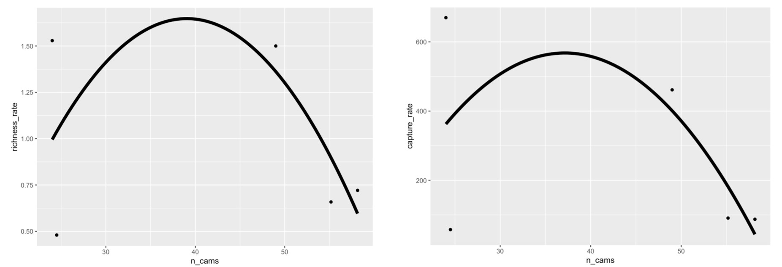**Figures and Tables**

**Figure 1. Scatter plot depicting the relation between the number of cameras (n_cams) and richness (left) and capture (right) rate. Smoothed conditional means are fitted to a linear model.**

**Table 1. Mixed Effect Model estimates and standard error (SE) are given for each ecosystem based on model for camera trap as sampling effort and the number of captures. Significant p-Values are bolded.**

|  |  |  |  |  |  |  |
| --- | --- | --- | --- | --- | --- | --- |
| **Ecosystem** | **Estimate** | **SE (±)** | **t-Value** | **ci.lb** | **ci.ub** | **p-Value** |
| **Coniferous** | 57.50 | 158.63 | 0.36 | -261.61 | 376.62 | 0.719 |
| **Deciduous** | 88.70 | 53.51 | 1.63 | -20.96 | 198.35 | 0.110 |
| **Desert** | 431.36 | 165.4 | 2.61 | 99.34 | 763.37 | **0.012** |
| **Grassland** | 525.22 | 120.85 | 4.35 | 282.10 | 786.34 | **<0.0001** |
| **Mixed Forest** | 297.10 | 226.91 | 1.31 | -159.39 | 753.58 | 0.197 |
| **Tropical** | 81.69 | 43.39 | 1.88 | -5.56 | 168.98 | 0.066 |

**Table 2. Mixed Effect Model estimates and standard error (SE) are given for each ecosystem based on model for camera trap as sampling effort and species diversity. Significant p-Values are bolded.**

|  |  |  |  |  |  |  |
| --- | --- | --- | --- | --- | --- | --- |
| **Ecosystem** | **Estimate** | **SE (±)** | **t-Value** | **ci.lb** | **ci.ub** | **p-Value** |
| **Coniferous** | 0.48 | 0.45 | 1.07 | -0.42 | 1.38 | 0.2913 |
| **Deciduous** | 0.65 | 0.16 | 4.18 | 0.34 | 0.96 | **0.0001** |
| **Desert** | 1.41 | 0.47 | 3.00 | 0.46 | 2.35 | **0.0043** |
| **Grassland** | 1.36 | 0.34 | 4.02 | 0.68 | 2.03 | **0.0002** |
| **Mixed Forest** | 3.80 | 0.77 | 4.93 | 2.25 | 5.34 | **<0.0001** |
| **Tropical** | 0.66 | 0.12 | 5.37 | 0.41 | 0.91 | **<0.0001** |

**Supplementary Appendix**

Papers obtained through database searching (Web of Science) Keywords:

Camera* Trap* AND Richness*, Diversity*, and Rarefaction* Curve*

(n= 515)

(n = 1090)

## Identification

Papers obtained from other sources, such as book chapter bibliographies

(n= 0)

## Eligibility

Records after duplicates removed   
(n = 397)

Records excluded for: relevance, review, opinion or idea paper, focus on one spices, qualitative, not English.

Records screened by abstract (n = 397)

## Screening

Full-text articles assessed for eligibility (n = 252)

(n = )

Full-text articles excluded:

Not reporting richness or diversity, number of records, and any measure of duration.

Include in synthesis

(n = 119)

## Included

Extracted data:

Location (latitude, longitude), camera trap days, number of records, animal richness, common name, scientific name, year, number of cameras, presence of bait, number of cameras, number of sites, and ecosystem.

**A. PRISMA diagram used for camera trapping effort systematic review (Moher et al. 2009). Search done with keywords: Camera* Trap* AND Richness*, Diversity*, and Rarefaction* Curve* in 2019.**

**B. Forest plots showing effect sizes for richness rate (left) and capture rate (right) in different ecosystems of study. 5 categories of ecosystems were simplified from system. Means with 95% confidence intervals are plotted. Values that have longer hortizonal lines indicate more spread in the studies. Values that are closer to the vertical dashed line are less different from the null effect.**

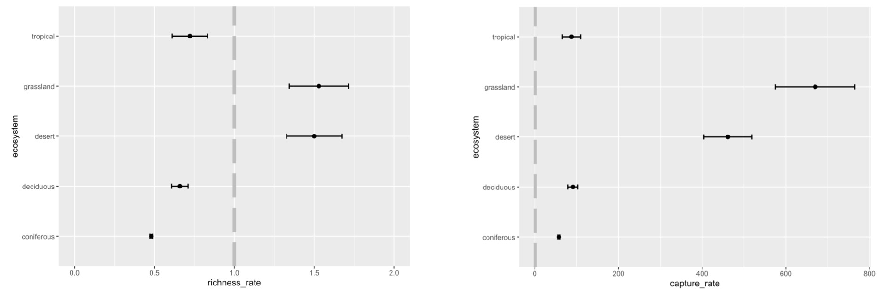

**C. Scatterplot showing the relationship between the number of camera trap study days and incidence rate for animal captures. Smoothed conditional mean is fitted using the linear model. Coloured dots represent different ecosystems.**

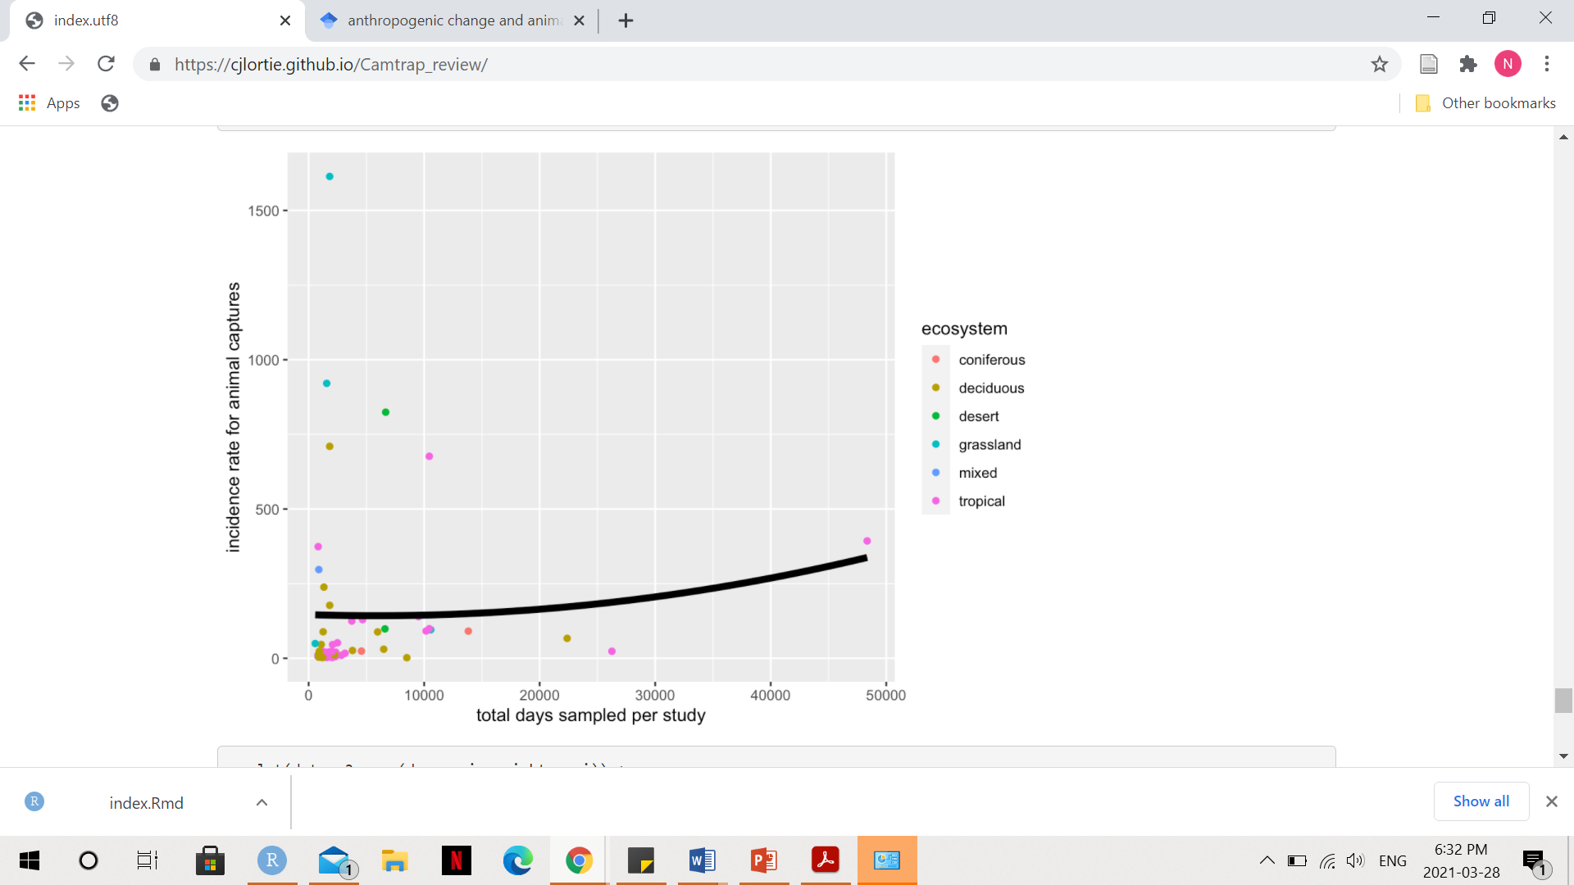

**D. Scatterplot showing the relationship between the number of camera trap study days and incidence rate diversity of animals detected. Smoothed conditional mean is fitted using the linear model. Coloured dots represent different ecosystems.**

